Bicycle Workstand Matrials List

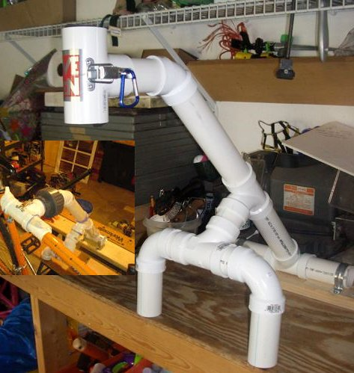

- 11/2 in PVC Pipe QTY 3 ft:
  - 2 in splices – 5 ea
    - 1 for T’s at mid-level joint
    - 2 for T to 90 degree elbows for forward legs
    - 2 for Union Joint (not shown) joining clamp to support
  - 7.5 in rear lower support – 1 ea
  - 9.5 in rear upper support – 1 ea
  - 4.5 in front legs – 2 ea
- PVC T-Fittings QTY 4
- 90 degree PVC Elbows QTY 2 (Front Leg assy)
- 45 degree PVC Fitting QTY 1
- PVC Union QTY 1
- 1in Hinge QTY 1 set
- Clasp/Latch QTY 1 set
- Conduit clamps or Plumbers tape to fit T-Fitting.
- Insulating Foam or Rubber Hose to fit between clamp and bike frame (I used 1” fuel hose for the frame and Water heater pipe insulation for inside the clamp).
10. PVC Primer and Glue

Notes:

- Our design incorporates 3 variations found at: http://www.instructables.com/id/PVC-Bench-top-Bike-Repair-Stand/. See photo inset for use of PVC Union.

- All PVC used for this project is Schedule 40. Heavier can be used but is more expensive.

The original instructions are as follows:

step 1Cut PVC parts to length
Parts List (PVC is 1 1/2" schedule 40): (4) Tees (2) 90 degree elbows (2) 45 degree elbows (4) Splices - 2" (1) Lower upright - 7 1/2" (1) Upper - 9 1/2" (1) Horizontal extension - 4 1/4" (2) Utility hinges - 1" (1) Clasp (2) Galvanized conduit clamps - 1 1/2" Foam pipe wrap PVC glue

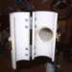step 2Cut the Tee for the clamp
I used a band saw (I used a table saw as seen in the video) to cut in half the PVC tee used to make the clamp. The cut needs to be pretty straight in order for the clamp to hinge properly.

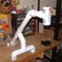step 3Assemble
Dry assemble all the PVC parts and mark them with a Sharpie for proper alignment when you're ready for final assembly. Glue all the pvc joints. You might want to take the extra step of cleaning all joints with PVC cleaner. You don't want your stand falling apart and your bike crashing to the floor. Install the hinges and clasp on the tee you cut in half to finish th…

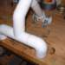step 4Attach to the bench top
Position the front legs of the stand near the front edge of the bench and use the 1 1/2" conduit clamps to hold the back of the stand securely to the bench.

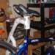step 5Use it
Wrap a 4" piece of foam pipe wrap around the seat post of your bike to protect it. Open the clamp and lift the bike so the seat post is inside the open clamp. Close the clamp and secure the clasp. Work on your bike.

