One Color T-Shirt Printer Plans
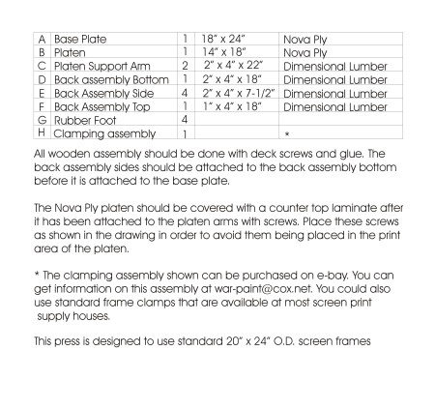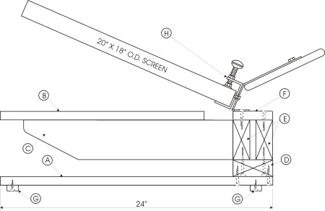
SIDE VIEW
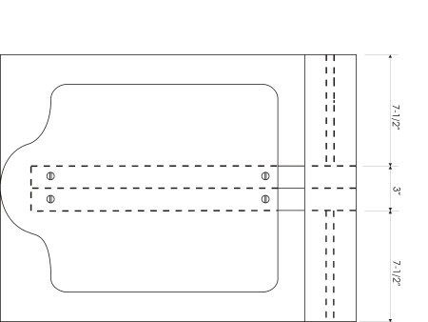
TOP VIEW
(Excludes Screen Frame and Clamp Assembly)
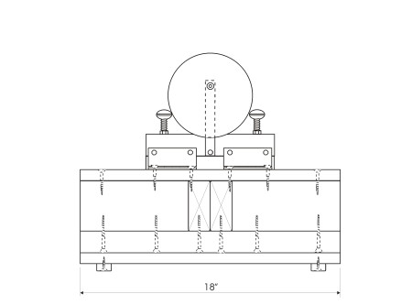
Rear View
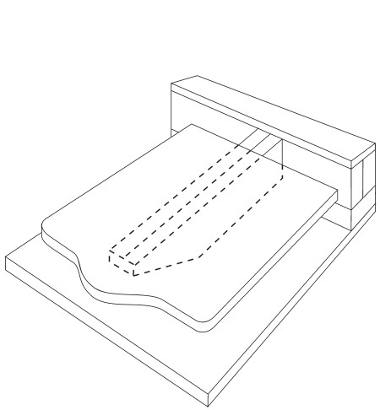
3D VIEW
(Excludes Screen Frame and Clamp Assembly)

